**Required Questions to Answer:**

Height (in)

Wrist to Floor Height

Price Range

**Optional Questions that will help specify the In-Home Kit:**

Handicap

-What’s your Handicap?

Typical Driver Distance

-What’s your average driving distance?

* Do you typically Hook or Pull Shots?

**Aesthetic Questions:**

Material Color?

Engravings?

Do Aesthetics Matter?

**First**: Required Questions to Answer

-How tall are you? If you are not sure, kindly estimate it.

-What is the height from your wrist to the floor?

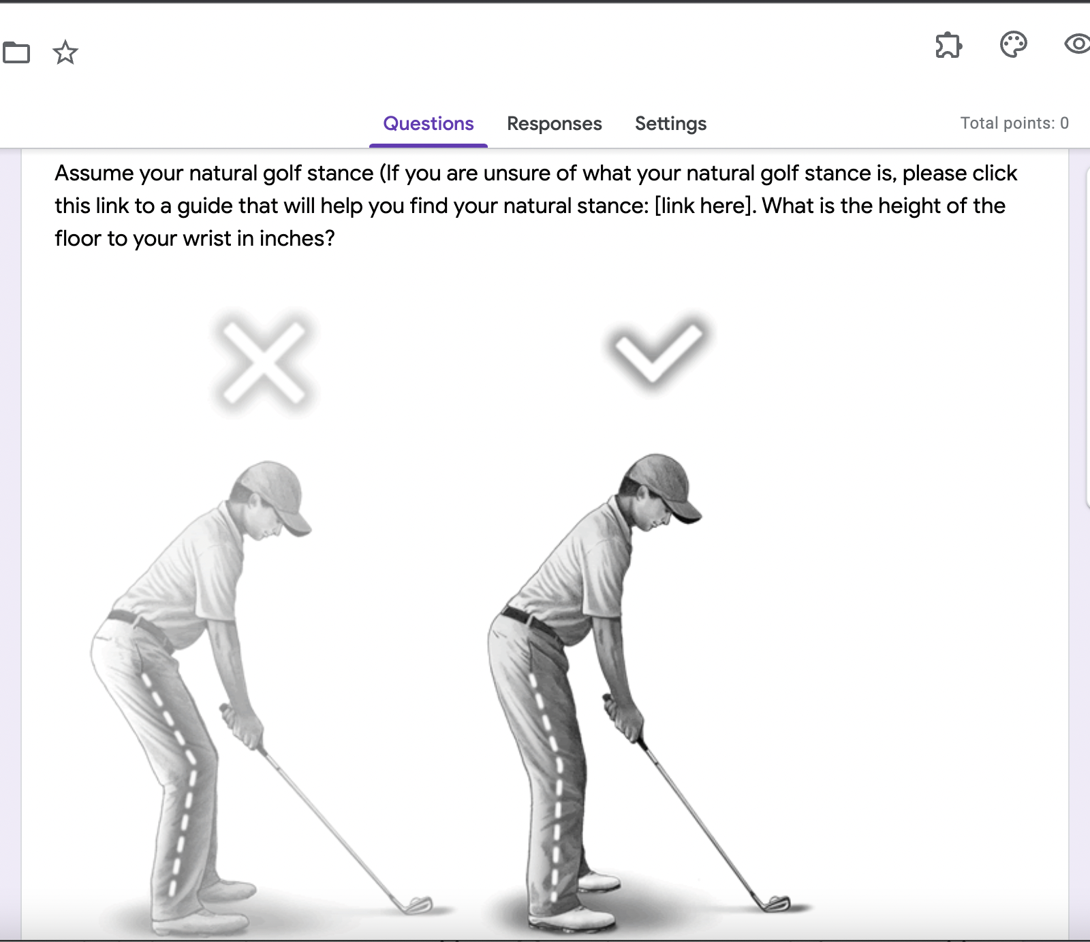

-Are your prices in line with your longer term business goals?

-What is the customer willing to pay?

-At what price would you consider the product to be so expensive that you would not consider buying it?

-At what price would you consider the product to be priced so low that you would feel the quality couldn’t be very good?

What is your price range?

**Second**: Optional Questions that will help specify the In-Home Kit:

**Third:** Aesthetic Questions

-Would you like to implement Aesthetic customization?

-Does static matter for your product of interest?

-Are you satisfied with the product’s looking style or would you like to customize it?

Interested in engravings? If so, what kind of engravings?

* Customizable Options:
  + Engravings
  + Color
  + Etc.